**BP315 Business Sub-Process Design Document**

**Integrated Inventory Optimization**

**My Concerto**

**SAP Integrated Business Planning**

Table of Contents

1 Overview 3

1.1 Change History 3

1.2 RASCI 3

1.3 Approval Detail 3

1.4 Other Related Documents 4

2 Business Process Overview 4

2.1 High level requirements 6

2.2 Key Value Drivers for the Business Process 6

2.3 Leading Practice Inputs 6

3 Business Sub-Process Description 7

3.1 Business Sub-Process diagram 9

4 Sub Process Activities 10

4.1 Activity List 10

4.2 Inbound Communication 12

4.3 Outbound Communication 13

4.4 Test Conditions 13

5 Sub-Process Variation 13

5.1 Business Unit Led 13

5.2 Geography/Legal Entity Led 13

6 Role Definition & Organisational Impact 13

6.1 Role/Skill Class Inventory 14

6.2 Role Summary 14

6.3 Organizational Impact 14

7 Process Fitness & Gap Analysis 14

7.1 Process Fitness 14

7.2 Gap Analysis 15

8 RICEFW 15

8.1 Reports 15

8.2 Interfaces (Inbound / Outbound) 15

8.3 Conversions 16

8.4 Enhancements 16

8.5 Forms 16

8.6 Workflows 17

9 Integration Points 18

9.1 Integration Issues 18

9.2 Other issues 18

# Overview

This Sub-process document describes the Inventory Optimization functionalities on SAP IBP.

## Change History

|  |  |  |  |  |
| --- | --- | --- | --- | --- |
| Ver. | Date | Summary of Changes | Author | Transport Number |
| New | 14-03-2017 | New | Raghunath Parthasarathy,Bibhu Prakash Das, Pallavi Dwivedi, Sandeep Chatterjee |  |
| 1.1 | 30-03-2020 | 1.Added details in section 1 & 2.1.  2.Updated the contents and template as part of the Quality review process | Geethika P |  |
|  |  |  |  |  |

## RASCI

|  |  |  |  |
| --- | --- | --- | --- |
| RASCI | Role | Name | Phone |
|  |  |  |  |
|  |  |  |  |
|  |  |  |  |

R: Responsible; A: Accountable; S: Support; C: Contribute; I: Information;

## Approval Detail

|  |  |  |  |
| --- | --- | --- | --- |
| Review # | Date | Name & Position of Approver | Signature |
|  |  |  |  |
|  |  |  |  |

## Other Related Documents

<Please insert links/references to related documents (issues, data entities, etc.)>

|  |  |
| --- | --- |
| Related Document | Comment |
|  |  |
|  |  |
|  |  |
|  |  |

# Business Process Overview

This sub process design document describes the Inventory Optimization process.

IBP for Inventory sets forward-looking inventory targets across the complex supply chain network such that inventory is deployed most efficiently to address the variability and uncertainty in demand forecast and supply (time and quantity) as per the specified service level.

Various factors such as lead time (transportation and production lead time), inventory holding cost rate and target service level are used to calculate the recommended safety stock, cycle stock and pipeline stock.

IBP- does this by utilizing multi-stage (multi-echelon) inventory optimization, and full detection and consideration of multiple demand and supply uncertainties for every product, sourcing relationship and time period in the complex network.

IBP for inventory helps to improve customer service and reduce cost and working capital requirements through better optimization.Apart from inventory optimization it also offers expected lost demand calculation. The following inventory components are defined for a combination of location product:

**Safety Stock**: Safety stock is the inventory needed to hedge against uncertainty. In simple terms safety stock depends on the target service level and the forecast error standard deviation.

**Cycle Stock**: This is the inventory needed to meet the current demand. It corresponds to the on hand inventory that exists to cover demand between shipments (replenishments). Cycle stock is primarily driven by the replenishment frequency (period between review).

**Pipeline Stock**: Subset of total pipeline stock and includes all inventory in the supply chain that is currently being moved from one location to another i.e. in-transit stock. The key drivers of pipeline stock are demand and lead time. This is the inventory needed to meet the future demand until the next order is received.

**Merchandise Stock**: The minimum inventory kept in a retail or customer-facing location. It may be used for showroom or demonstration purposes but is typically included in inventory available to meet demand.

**Target Inventory Position**: The target inventory position is the sum of the inventory components for a location product. Target Inventory Position is used to calculate the working capital by multiplying with the inventory holding cost rate.

The various factors affecting the inventory components are lead time, target service level and the forecast error variability (coefficient of variation).

SAP IBP provides the following operators for executing the optimization algorithm runs:

* Global (Multi-Stage) Inventory Optimization: The Global (multi-stage) inventory optimization operator is used to recommend safety stock across all products and locations of the supply chain
* Decomposed (single stage) inventory optimization: It calculates the Recommended Safety Stock and Target Inventory Position locally for a location product. Some of the inputs in this operator are taken from (Multi-Stage) Inventory Optimization operator and hence needs to be run as a prerequisite to the single stage inventory optimization operator
* Calculate Forecast Error CV: Forecast error is a statistical measure of forecast accuracy used to estimate the variability of the underlying demand. The Calculate Forecast Error CV operator calculate the forecast error coefficient of variation, which is the difference between forecasted and actual demand
* Calculate Target Inventory Components: This operator the types of inventory that comprise the total inventory for a given item to support a more granular inventory optimization calculation. Some of the inputs in this operator are taken from Global (Multi-Stage) Inventory Optimization operator and hence needs to be run as a prerequisite to the single stage inventory optimization operator

Manage Forecast Error calculations – Inventory Optimization OR Calculate Forecast Error CV

Global (Multi-stage) Inventory Optimization

Calculate target Inventory Components

Decomposed (Single- Stage ) Inventory Optimization

## High level requirements

* The combined final demand from Demand planning should be sent to Inventory planning as Demand forecast .

## Key Value Drivers for the Business Process

* Planner gets the visibility of all these inventory drivers and consider them all in their planning
* Compare the target and actual revenue
* Enable organization to optimally collaborate and address critical, cross-functional business decision across product life cycle
* Different KPIs can be configured based on the business requirement
* Costs are available for upload and calculation
* Process templates, so you can quickly and easily create a planning process
* Task completion monitoring is done in % value
* Administrator must enable SAP Jam integration with SAP Integrated Business Planning so that analytics, collaboration, and feed can be viewed.
* Key figure Calculations impact is kept Updated and informed to Planner
* Manual work of checking figures is avoided

## Leading Practice Inputs

* Cases and tasks are used to track, manage, and resolve supply chain problems.
* Tasks are delegated to individuals to track which actions have occurred in the case.
* Real time Value calculation and impact displayed
* Prompt actions can be taken by planners for value corrections
* Planning is timely and responsive

# Business Sub-Process Description

* Inventory Planning and Optimization Setup

Inventory Planning and Optimization setup in the IBP Web UI would enable us to execute Inventory Optimization profiles such as Global (multi-stage) inventory optimization, decomposed (single-stage) inventory optimization and Expected Lost demand in the IBP Excel UI.

These algorithms consider different factors into account such as Material locations, Demand forecast, Fill rates, Service levels, Inventory holding cost and gives the optimized Safety stock and target inventory position for different item – location combinations.

* IBP Run Inventory Optimization Algorithm

Once the IO forecast is derived using the available forecast techniques, a set of Inventory Optimization algorithms helps to compute recommended inventory levels or expected lost demand for the supply chain network.

Inventory Planning and Optimization Setup

Inventory Optimization support following Planning operators: - following profiles:

**1. Global Multi-Stage Inventory Optimization**

The Global (multi-stage) inventory optimization operator recommends the safety stock across all products and locations in the supply chain by minimizing the total safety stock holding cost while ensuring that all customer service level targets are met.

The main functions done by this operator are:

* Optimizes safety stock globally and simultaneously across all products and locations of a supply chain.
* Propagates forecast and forecast variability to stocking nodes that have customer demand as well as internal nodes of the Supply chain network.
* Optimizes internal service levels between internal (upstream) nodes of the supply chain network.
* Calculates safety stock targets, backorders, average expedited quantities.

**2. Calculate Target Inventory components**

After running the Global (multi-stage) inventory optimization operator,Target inventory Components operator is run to arrive at the ‘Target Inventory Position’  which calculates the types of inventory that comprise the total inventory for a given item to support a more granular inventory optimization calculation. The main functions done by this operator are:

* Runs a calculation with respect to optimal inventory targets.
* Estimates target, average quantities, and currency values of inventory position, on-hand stock, cycle stock, pipeline stock and merchandising stock.
* Calculates reorder point and values for the whole network.

**3.Decomposed (Single stage) inventory Optimization**

This operator Optimizes recommended safety stock locally for each customer-facing product-location combination in a decomposed manner. This operator is ideal for running simulations where you want to determine the impact on recommended safety stock for local changes to input key figures after multi-stage inventory optimization has been run.

**4. Forecast Error CV Calculator**

Calculates the forecast error coefficient of variation, that is, the difference between forecasted and actual demand. Forecast error is a statistical measure of forecast accuracy used to estimate the variability of the underlying demand

**5. Impact of Service Level on Inventory Components**:

The Target Service Level represents the percentage of orders that are fulfilled and is set during the S&OP meeting. The target service level primarily affects the safety stock component.

The impact of change in service level can be simulated to determine the change in inventory stock. Target service level is one of the inputs in the Global (Multi-Stage) Inventory Optimization operator. One of the outputs of Global (Multi-Stage) Inventory Optimization operator is recommended safety stock. To check the impact on Target Inventory Position, the Target Inventory Components operator is run. The two operators are run in sequence to check the impact of change in service level.

**6. Impact of Lead Time on Inventory Components:**

Lead time required to replenish stock at a location is the sum of the transportation and production lead times. Change in transportation lead time affects the safety stock and the pipeline stock.

To check the impact of change in service level on safety stock the Global (Multi-level) Inventory Optimization operator is run followed by Target Inventory components operator.

**7. Impact of Forecast Accuracy on Inventory Components:**

The forecast accuracy is calculated using the ‘Calculate Forecast Error CV’ operator. The inputs to this operator are Demand Forecast and Actual Sales.

After the Calculate Forecast Error CV operator is run the impact of change on the safety stock can be checked using the Global (Multi-level) Inventory Optimization operator

## Business Sub-Process diagram

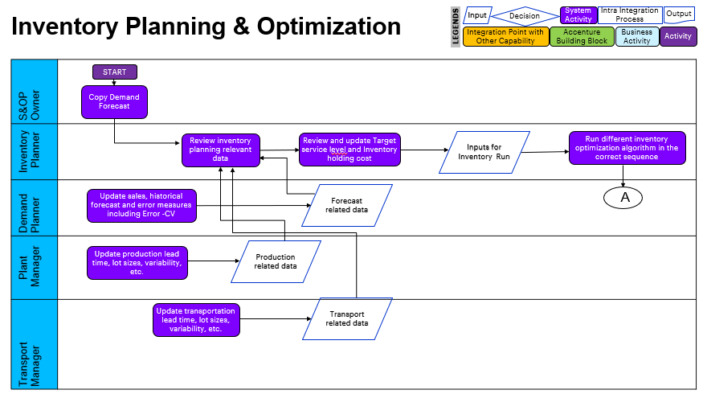

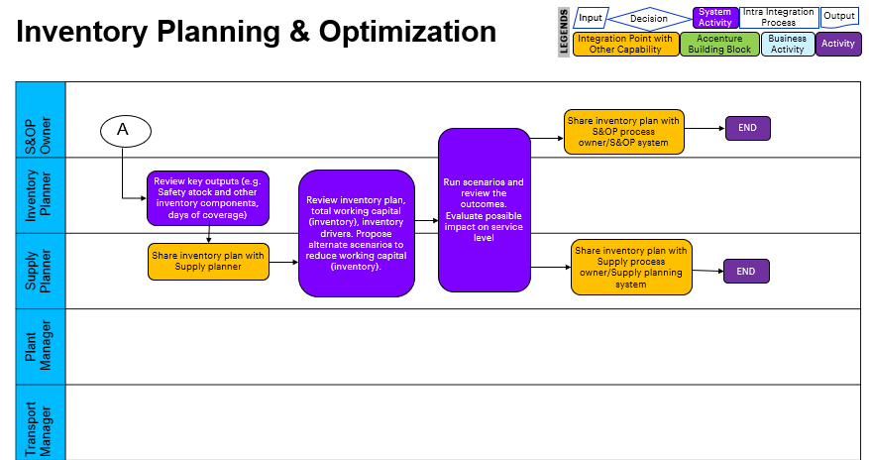

# Sub Process Activities

## Activity List

It maps to the BP317, Activity definition document if applicable for the project & also has references in the process/sub process diagram.

|  |  |  |  |  |
| --- | --- | --- | --- | --- |
| Name | Description | Transaction Code,  if relevant | Roles involved | Regulatory /Other Controls |
| Set up Attributes and Master Data for all Process steps | This step requires you to create master data, attributes or characteristics relevant for planning such as Product ID, product description etc. for custom Model |  |  |  |
| Set up Unified Planning Area and Planning Level | Create a set of configuration elements that define the structure of a process. Similarly planning levels must be set up as the combination of attributes to perform planning. |  |  |  |
| Set up Key Figure and Calculations for all Process steps. | Key figures also offer the flexibility of calculations as per user defined formulae |  |  |  |
| Configure the KPIs and required Key Figures in the Web UI. | Firstly, create and configure all the required input Key Figures which would be used in the calculation of different Demand Plan KPIs and then create and configure various KPIs Key Figure along with their calculation definition |  |  |  |
| Check for Planning Operators assignment | Assign the required planning operators to the planning area like Copy operators, etc. and click on activate to activate the planning area. |  |  |  |
| Copy demand for Demand Forecast | Run Copy Combined Final Demand to Demand Forecast IO operator. The demand Forecast values gets populated |  |  |  |
| Provide demand, production, transportation and cost inputs | Inputs required calculation are entered/loaded. Target service level, lead times, inventory holding cost rate are entered. |  |  |  |
| Calculate Forecast Error Coefficient of Variation | The Calculate Forecast Error CV operator is run to calculate the forecast variation from demand forecast and sales. |  |  |  |
| Run Global (Multi-stage) Inventory Optimization | The Global (Multi-stage) Inventory Optimization operator is run to propagate forecast, optimize internal service level and calculate inventory targets |  |  |  |
| Run the Target Inventory Components operator | The inventory components Cycle stock, Pipeline stock and Target Inventory Position are populated |  |  |  |
| Run Expected Lost Demand operator | The expected lost demand and expected lost demand value are populated |  |  |  |
| Run Safety Stock Simulations | Safety Stock simulations are ran to strike a right balance of Safety Stock for different product location combinations |  |  |  |
| Review simulation results and finalized safety stock | The different scenarios are compared with each other and the most relevant scenario is promoted to the baseline |  |  |  |
| Review and update Parent and Components Relationship | Parent Component relationship gives us details as to which how many components for a particular product needs to be ordered. It also helps in updating the component count in case less/more components need to be ordered. |  |  |  |
| Review and run Inventory Optimization for components | Input Output for Components is another important step as it is useful to track the target inventory position. Warehousing is another cost of holding excess inventory in a business.  The cost of warehousing can include the warehouse space, utilities and maintenance of the storage area hence it becomes necessary to keep a proper check on the inventory level to be maintained. |  |  |  |
| Review the recommended results and finalize the inventory plan | Once all the values are reviewed and updated as per business needs, the inventory plan will be finalized. |  |  |  |
| Review PBR and analyse the impact on the inventory Plan | Update the different PBR value under each new scenario in the PBR view in the excel UI and analyze the output (RSS & TIP) after multistage IO run |  |  |  |
| Review Production Lot size and analyze the impact on the inventory Plan | Update the different Production Min lot size and Production incremental Lot size value under each new scenario in the PBR view in the excel UI and analyze the output after multistage IO run. |  |  |  |
| Review Transportation Lot size and analyse the impact on the inventory Plan | Update the different Transportation Min lot size and Transportation incremental Lot size value under each new scenario in the PBR view in the excel UI and analyze the output after multistage IO run. |  |  |  |
| Update the Supply chain network and analyse the impact in the inventory. | Update the supply chain network by maintaining Master Data and KF data in via Excel or Web UI and analyze the output in Excel UI after multistage ID run |  |  |  |

## Inbound Communication

The Inbound Communication needs to be specifically documented for the client specific situation, like interfacing with external systems, workflow, form & Medium of communication.

<Enter text here>

<Start bulleted text here – leave one character space after the bullet>

|  |  |  |  |  |
| --- | --- | --- | --- | --- |
| Activity | Type (email, form, handoff, etc) | Automatic/Manual | Source | Description |
|  |  |  |  |  |
|  |  |  |  |  |

## Outbound Communication

The Outbound Communication needs to be specifically documented for the client specific situation, like interfacing with external systems, workflow, form & Medium of communication.

|  |  |  |  |  |
| --- | --- | --- | --- | --- |
| Activity | Type (email, form, handoff, etc) | Automatic/Manual | Source | Description |
|  |  |  |  |  |
|  |  |  |  |  |

## Test Conditions

This section captures Test conditions for this sub process for the any specific client requirements. Generic test conditions for this sub process will be within the AAES test scripts.

<Enter text here>

<Start bulleted text here – leave one character space after the bullet>

|  |  |  |
| --- | --- | --- |
| Number | Test Condition – Action | Expected Result |
|  |  |  |
|  |  |  |

# Sub-Process Variation

<Enter text here>

<Start bulleted text here – leave one character space after the bullet>

## Business Unit Led

None

## Geography/Legal Entity Led

None

# Role Definition & Organisational Impact

The content in this section will serve as input for the training and performance support team’s deliverables.

<Enter text here>

<Start bulleted text here – leave one character space after the bullet>

## Role/Skill Class Inventory

|  |  |  |
| --- | --- | --- |
| Role | Skills | Knowledge |
|  |  |  |
|  |  |  |
|  |  |  |

## Role Summary

|  |  |  |
| --- | --- | --- |
| Role | List of Steps | SAP Transaction |
|  |  |  |
|  |  |  |

## Organizational Impact

|  |  |  |  |  |
| --- | --- | --- | --- | --- |
| Reference # | Impact Description | Impact (H/M/L) | Impact Type | Impacted Groups |
|  |  |  |  |  |
|  |  |  |  |  |
|  |  |  |  |  |

# Process Fitness & Gap Analysis

<Enter text here>

<Start bulleted text here – leave one character space after the bullet>

## Process Fitness

|  |  |  |  |  |
| --- | --- | --- | --- | --- |
| Req ID | Short Description | Long Description | Req. Type | Accenture Reusable Assets |
|  |  |  |  |  |
|  |  |  |  |  |

## Gap Analysis

|  |  |  |  |  |  |  |
| --- | --- | --- | --- | --- | --- | --- |
| Country/ Region/ Business Impacted | Gap Description | Legal Req. (Y/N) | Magnitude of Impact (L/M/H) | Solution Type | RICEFW No. | Ref. to Req. id. |
|  |  |  |  |  |  |  |
|  |  |  |  |  |  |  |

# RICEFW

<Enter text here>

<Start bulleted text here – leave one character space after the bullet>

## Reports

|  |  |  |  |  |  |
| --- | --- | --- | --- | --- | --- |
| Client XYZ  RICEFW # | Report Description | Complexity (H/M/L) | Comments | Use from myConcerto/ARTL (New/Rework/Rep) | Ref # from RICEFW inventory |
|  |  |  |  |  |  |
|  |  |  |  |  |  |
|  |  |  |  |  |  |

## Interfaces (Inbound / Outbound)

|  |  |  |  |  |  |
| --- | --- | --- | --- | --- | --- |
| Client XYZ  RICEFW # | Interface Description | Complexity  (H/M/L) | Comments | Use from myConcerto/ARTL (New/Rework/Rep) | Ref # from RICEFW inventory |
|  |  |  |  |  |  |
|  |  |  |  |  |  |

## Conversions

This section to be completed by the Process Team with assistance from the Master Data Management Team

|  |  |  |  |  |  |
| --- | --- | --- | --- | --- | --- |
| Client XYZ  RICEFW # | Conversion Description | Complexity  (H/M/L) | Comments | Use from myConcerto/ARTL (New/Rework/Rep) | Ref # from RICEFW inventory |
|  |  |  |  |  |  |
|  |  |  |  |  |  |

## Enhancements

|  |  |  |  |  |  |
| --- | --- | --- | --- | --- | --- |
| Client XYZ  RICEFW # | Enhancement Description | Complexity  (H/M/L) | Comments | Use from myConcerto/ARTL (New/Rework/Rep) | Ref # from RICEFW inventory |
|  |  |  |  |  |  |
|  |  |  |  |  |  |

## Forms

|  |  |  |  |  |  |
| --- | --- | --- | --- | --- | --- |
| Client XYZ RICEFW # | Form Description | Complexity (H/M/L) | Comments | Use from myConcerto/ARTL (New/Rework/Rep) | Ref # from RICEFW inventory |
|  |  |  |  |  |  |
|  |  |  |  |  |  |

## Workflows

|  |  |  |  |  |  |
| --- | --- | --- | --- | --- | --- |
| Client XYZ RICEFW # | Workflow Description | Complexity (H/M/L) | Comments | Use from myConcerto (New/Rework/Rep) | Ref # from RICEFW inventory |
|  |  |  |  |  |  |
|  |  |  |  |  |  |

# Integration Points

Generic Integration touch points have been highlighted in this section. It covers dependencies or prerequisites arising from other processes or sub processes. This information should lead to cross functional discussions between different work streams to sort out the interdependencies.

<Enter text here>

<Start bulleted text here – leave one character space after the bullet>

## Integration Issues

|  |  |  |  |  |
| --- | --- | --- | --- | --- |
| Issue # | Issue Description | Impact | Status | Resolution |
|  |  |  |  |  |
|  |  |  |  |  |

## Other issues

|  |  |  |  |  |
| --- | --- | --- | --- | --- |
| Issue # | Issue Description | Impact | Status | Resolution |
|  |  |  |  |  |
|  |  |  |  |  |

#### Revision History

|  |  |  |  |
| --- | --- | --- | --- |
| Date | Version | Description | Author |
| DD/MM/YYYY |  |  |  |
|  |  |  |  |
|  |  |  |  |